**Manuals for ‘Manage Video’**

**Brief of the ‘Manage video gallery’ –** This is the page where we manage video.

**1. How to manage Video-.**

Steps:

1. Login to the site and go to ‘Media Room’ tab and click on ‘Manage Video’.
2. On ‘Manage Video’ page the listing of video and ‘Add video’ button will display.
3. On this page we can edit and delete the existing records.
4. Click on ‘Add video’ button for add new video.
5. The added new video will display on home page video gallery section and video gallery page.

1.

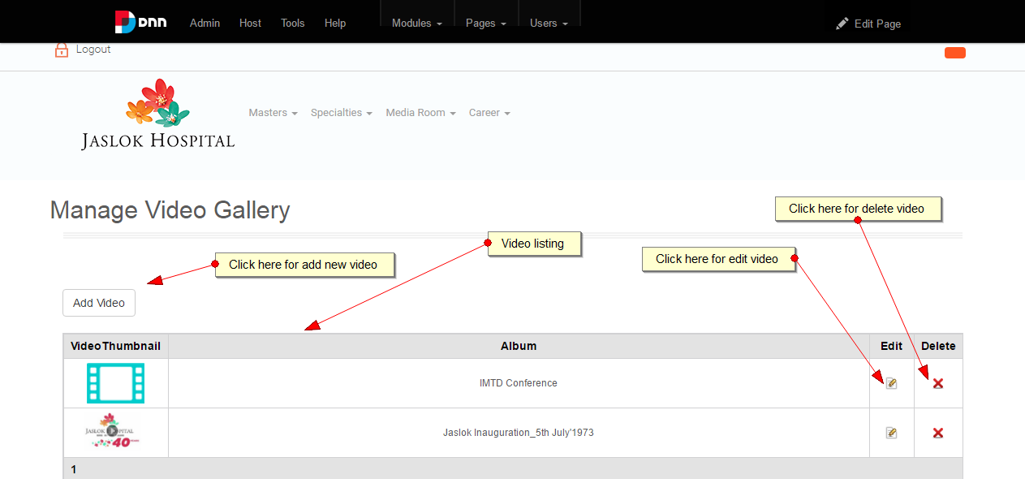

2.

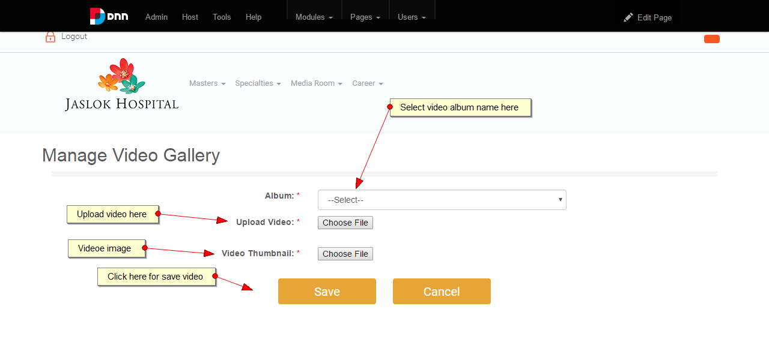

3.

